ACKNOWLEDGEMENT

I would like to express my gratitude to my project guide Prof. Bhavesh Oza for his guidance, advice and constant support throughout our work. I would like to thank him for being my advisor here at L.D. College of Engineering, Ahmedabad.
Next, I wants to express my respects to professors of my department for teaching me and also helping me how to learn. They have been great sources of inspiration to me and I thanks them from the bottom of heart.
I would like to thank all my friends and especially my classmates for all the thoughtful and mind stimulating discussions I had which prompted us to think beyond the obvious. I have enjoyed their companionship so much during my studies at LDCE, Ahmedabad.
I amespecially indebted to my parents for their love, sacrifice, and support. They are my first teachers after Icame to this world and have set great examples for me about how to live, study and work.

ABSTRACT

The basis for the Secure It Pro is recognition of a need for improving an existing system or procedure. This involves a preliminary study or initial investigation to determine whether a new Security Application can solve the problem. It entails looking into an inefficient existing apps or whether parts of the apps can be combined in single app. The single app is not available for meeting the security requirement of user. Hence new single app Secure It Pro is needs to be developed which provides integrated environment.

INDEX
1 Introduction 1
1.1 Purpose 1
1.2 Objective 1
1.3 Overview 1
1.4 Scope 2
1.5 Benefits 2
1.6 Definitions, Acronyms, and Abbreviations 3
2 General Description 4
2.1 Product Perspective 4
2.2 Product Functions 4
2.3 General Constraints 4
3 Project Management 5
3.1 Project Planning & Scheduling 5
3.1.1 Software Development Life Cycle 5
3.2 Scheduling 7
4 System Specific Requirement 8
4.1 Functional Requirements 8
4.1.1 App-lock Module Requirement 8
4.1.2 Data Hiding Module Requirement 11
4.1.3 Emergency Calling Module Requirement 14
4.1.4Anti-Theft Module Requirement 16
4.2 Non Functional Requirements 20
4.3 Hardware Requirements 20
4.4 Anticipated Work Environment 21
4.4.1 Java OOPs Concepts 21
4.4.2 Android 22
4.4.3 Android SDK 23
4.4.4 AVD & AVD Manager 24
4.4.5GENYMOTION Emulator 24
4.4.6 JSP (Java Server Pages) 25
4.4.7 JAVA Servlet 25
5 UML Diagrams 26
5.1 Use case Diagrams 26
5.2 Sequence Diagrams 30
5.3 Flowcharts 34
5.4 Class Diagram 51
5.5 Deployment and component diagram 52
6 Design and Layouts 53
6.1 Layouts 53
6.2 Data Dictionary 67
6.3 Code Details (Code Snippet) 69
7 Testing 75
7.1 Test Plan And Test Method 75
7.1.1 Test Plan 75
7.1.2 Test method 75
7.2 Test Cases 76
7.2.1 Test Case for User Login[Valid] 76
7.2.2 Test Case for User Login[Invalid] 77
7.2.3 Test Case for User Registration 78
8 Future Plan and Conclusion 79
8.1 Future Plan 79
8.2 Conclusion 79
9 Bibliography 80
9.1 Websites 80
9.2 Books 80
10 Appendix 81
10.1 Periodic Progress Reports (PPR) 82
10.2 Business Model Canvas & Report 86
10.3 Patent Drafting Exercise Report 91

1 Introduction

Purpose

Objective
Overview
Scope
Benefits
Definitions, Acronyms, and Abbreviations

1.1 Purpose
The purpose of this document is to define the requirements for creating an Android application (Secure It Pro). This document will outline all of the necessary information to start development.

1.2 Objective
In the world of smartphones, there are many android apps for security of data, mobile and apps, but main disadvantage of these apps are that they are needed to install separately. They are not available in single app and individual apps consumes more RAM.
Imagine, if all these features are available in a single application then the user need not to install all the applications separately. Our project is about develop such application.

1.3 Overview
Secure It Pro has four modules.
• One Touch Calling
• Anti-Theft
• App Lock
• Data Hiding
One Touch Calling module is useful in emergency situation. Using this application, user can call to predefined contact by one touch.
Anti-Theft module is for securing mobile from thieves. This module send message to predefined contact on inserting a SIM card with different number which does not match with provided number while installation of application. User can trace his device from website as well.
App Lock module provides facility for locking of specific applications. To open application locked by App Lock, user have insert a password.
Data hiding module provides facility of data hiding. This module hide personal data. To show this data user have to insert password.
Thus, this app provide most of all necessary security features in single package.

1.4 Scope
(1) This application is only for android OS. This application is supported by android OS 4.0 and above. To run this application, it is necessary to have RAM more than 512 MB, processor having 834GHz and internal memory more than 512MB.
(2) Secure it pro contains anti-theft module, which may not run on android OS having dual SIM.

1.5 Benefits
Secure It Pro provides following benefits.
- All applications comes in single package
- Consumes less RAM
- Consumes less Memory
- Consumes less Battery
- Better user interface
- Live tracing
- Also provides features of one touch calling
- Provides integrity

1.6 Definitions, Acronyms, and Abbreviations

SIM - Subscriber Identity Module
IMSI - International Mobile Subscriber Identity
IMEI - International Mobile Equipment Identity
UML - Unified Modeling Language
API - Application Programming Interface

2 General Description

Product Perspective

Product Function
General Constraints

2.1 Product Perspective
In current situation smart phones uses different types of application for providing various types of security. Our application provide integrity by combining all these functionality within one package. It provides support for hiding personal data, app lock, anti-theft, emergency call. Android phones having OS 4.0 and above are able to use this application.

2.2 Product Functions
Stakeholders of the application are as follows:
- Smartphone Users: Download application from googleplaystore and install it. Configure the application.
- Thief: Try to crack the password.
- Non-Regular User: Try to open application installed in mobile. Try to access personal data.
- Mobile Station: Track the IMSI number and send it to registered number.

2.3 General Constraints
This application will run on android mobile having OS 4.0 and above versions. It is necessary to have RAM 512 MB and not have dual SIM mobile. This application required administrative control.

3 Project Management

Project Planning & Scheduling

Risk Management

Scheduling

3.1 Project Planning & Scheduling

3.1.1 Software Development Life Cycle
- Software Development Life Cycle (SDLC) is a diagrammatical representation of various activities required to fulfill the process by which System Analyst, Software Engineers & Programmers depict the information & build the computer applications to solve business problems & needs.
Software Process Model:
- The project is based on the evolutionary process model. To cover all aspects of the application the whole process has to be divided in various modules and work on it according to need. This method can be appropriately achieved by this model.
Incremental Model:
- In incremental model the whole requirement is divided into various builds. Multiple development cycles take place here, making the life cycle a“multi-waterfall” cycle. Cycles are divided up into smaller, more easily managed modules. Each module passes through the requirements, design, implementation and testing phases. A working version of software is produced during the first module, so you have working software early on during the software life cycle. Each subsequent release of the module adds function to the previous release. The process continues till the complete system is achieved.

- In the diagram above when we work incrementally we are adding piece by piece but expect that each piece is fully finished. Thus keep on adding the pieces until it’s complete. As in the image above a person has thought of the application. Then he started building it and in the first iteration the first module of the application or product is totally ready and can be demoed to the customers. Likewise in the second iteration the other module is ready and integrated with the first module. Similarly, in the third iteration the whole product is ready and integrated. Hence, the product got ready step by step.

Figure 1 Incremental Model
3.1.2 Software Project Scheduling
“Software project scheduling is an activity that distributes estimated efforts across the planned duration by allocating the effort to specific software engineering tasks.”
Proper Scheduling requires:
- All tasks appear in network.
- Proper effort and timing are allocated to each task.
- Interdependencies between tasks are properly indicated.
- Resources are allocated for the work to be done.

3.2 Scheduling

Title | Starting Date | Ending Date
Planning | 15th July 2014 | 30TH JULY 2014
Analysis | 1st August 2014 | 30TH AUGUST 2014
Design | 21st September 2014 | 10TH NOVEMBER 2014
Coding | 1st January 2015 | 25TH FEBRUARY 2015
Testing | 1st March 2015 | 15TH MARCH 2015

4 System Specific Requirement

Functional Requirement

Non-Functional Requirement
Hardware Requirement
Anticipated Work Environment

4.1 Functional Requirements

4.1.1 App-lock Module Requirement

4.1.1.1: Set password.
- Description:
Insert a password having minimum length of 4 characters which is used to open the locked application.
- Input:
Insert a password in a set password textbox and re-entered the same password in confirm password textbox.
- Output:
Redirect to the lock-cart.
- Processing:
Check for password format and also compare password and re-entered password. If condition satisfied then redirect to the lock-cart.

4.1.1.2: Change password.
- Description:
Insert a new password with proper format.
- Input:
Insert old password, new password and re-enter new password in respective textboxes.
- Output:
Redirect to the lock-cart.
- Processing:
Validate old password, and check format of new password. Compare new password and re-entered new password.If all condition satisfied then redirect to the lock-cart.

4.1.1.3: Select app to lock-cart.
- Description:
Select installed application to insert it to lock-cart.
- Input:
Select application one by one from the list fragment.
- Output:
Selected application are added to lock-cart.
- Processing:
Provide flag to the application. When application start, Applock provides lock screen.

4.1.1.4: Remove application from lock-cart.
- Description:
Select application from lock-cart to remove it from lock protection.
- Input:
Select application one by one from the lock-cart.
- Output:
Application removed from lock-cart.
- Processing:
Application removed from lock protections.

4.1.1.5: Run applock module.
- Description:
Run applock module on startup of application which is available in lock-cart.
- Input:
Enter password to open the application.
- Output:
Application start if the password is valid.
- Processing:
Applockmodule compare the password with the saved password. If password matches, application starts.

4.1.2 Data Hiding Module Requirement

4.1.2.1: Set password.
- Description:
Insert a password having minimum length of 8 characters which is used to open the data hiding module.
- Input:
Insert a password in a set password textbox and re-entered the same password in confirm password textbox.
- Output:
Redirect to the data hiding.
- Processing:
Check for password format and also compare password and re-entered password. If condition satisfied then redirect to the data hiding.
4.1.2.2: Hide Data.
- Description:
Select files from file manager to hide it.
- Input:
Select files from file manager and hide them into particular folder.
- Output:
Files will be invisible to the user.
- Processing:
Selected files will move from file manager to particular folder in data hiding module.

4.1.2.3: Change password.
- Description:
Insert a new password with proper format.
- Input:
Insert old password, new password and re-enter new password in respective textboxes.
- Output:
Redirect to the data hiding.
- Processing:
Validate old password, and check format of new password. Compare new password and re-entered new password.If all condition satisfied then redirect to the data hiding.

4.1.2.4: Unhide data.
- Description:
User can unhide the hidden files from hidden folder.
- Input:
Select files from data hiding module to unhide it.
- Output:
Files will be visible to all user.
- Processing:
Files properties will be changed from hidden to unhidden.

4.1.2.5: Set dummy password.
- Description:
Insert a dummy password having minimum length of 8 characters which is used to open the data hiding module with no files.
- Input:
Insert a dummy password in a set dummy password textbox and re-entered the same password in confirm dummy password textbox.
- Output:
Redirect to the data hiding.
- Processing:
Check for password format and also compare password and re-entered password. If condition satisfied then redirect to the data hiding.

4.1.3 Emergency Calling Module Requirement

4.1.3.1: Provide two numbers for emergency call.
- Description:
Provide two number which is used for one touch calling in emergency situation.
- Input:
Enter primary number in textbox-1 and secondary number in textbox-2.
- Output:
Numbers are successfully set up for one touch calling.
- Processing:
Add numbers to the “PreferenceManger”.

4.1.3.2: Call Forward.
- Description:
If one number is busy then call is forward to the second number.
- Input:
Call Status of 1st number is busy.
- Output:
Call to the second number as saved in Emergency calling.
- Processing:
Check call status of 1st number and forward it to the second number if 1st number is busy.

4.1.3.3: Change the given number
- Description:
If user wants to change number, he can change it.
- Input:
Insert another number/s in the textbox.
- Output:
Number/s will be changed.
- Processing:
Check call status of 1st number and forward it to the second number if 1st number is busy.

4.1.3.4: Create widget.
- Description:
Once the secure it pro application installed successfully, widget for emergency calling module automatically created.

4.1.4Anti-Theft Module Requirement

4.1.4.1: Set password.
- Description:
Insert a password having minimum length of 8 characters which is used to prevent mobile from thief.
- Input:
Insert a password in a set password textbox and re-entered the same password in confirm password textbox.
- Output:
Redirect to the anti-theft module.
- Processing:
Check for password format and also compare password and re-entered password. If condition satisfied then redirect to the anti-theft module.
4.1.4.2: Change password.
- Description:
Insert a new password with proper format.
- Input:
Insert old password, new password and re-enter new password in respective textboxes.
- Output:
Redirect to the anti-theft module.
Processing:
- Validate old password, and check format of new password. Compare new password and re-entered new password.If all condition satisfied then redirect to the anti-theft module.
4.1.4.3: Provide number for anti-theft.
- Description:
User provides number where he wants to send details of the SIM card when his mobile is stolen.
- Input:
Insert mobile number in textbox.
- Output:
Number is setup successfully for anti-theft module.
- Processing:
Number is saved in “PreferenceManager”.

4.1.4.4: Change number.
- Description:
If user wants to change given number, he can change it.
- Input:
Insert new numbers in new number textbox.
- Output:
Number is changed and saved successfully.
- Processing:
Number is changed in “PreferenceManager”.

4.1.4.5: Run the anti-theft module on startup (if SIM card is replaced).
- Description:
If anybody steal the mobile and try to change SIM card, then he must require to enter password on start up.
- Input:
Insert new SIM card.
- Output:
New SIM detect and Run the anti-theft module.
- Processing:
Anti-theft module detects new SIM card and it asks password from the user.

4.1.4.6: Send message on registered number.
- Description:
If password is find invalid then message with SIM details is forwarded to the saved mobile number.
- Input:
Insert an anti-theft password.
- Output:
Message is send if password is wrong.
- Processing:
Anti-theft validate the password and if the password is wrong then message is sent to the registered number.

4.1.4.7: Trace device online through website
- Description:
User can search and trace his registered device through website.
- Input:
Login into website through username and password.
- Output:
Device location is shown on the google map.
- Processing:
Website uses database and locate device.

Non Functional Requirements

- Efficiency
Consume less RAM in android system and faster than app available in playstore market.
- Integrity
Such kind of application available in playstore market but those consume more RAM in system. This application integrate such kind of application and consume less RAM.
- Availability
Application always run in background.
- Security
Application has administrative constraints so that nobody can uninstall it without entering password.
- Maintenance
Application will be updated according to requirement.

Hardware Requirements

- Capable of running Android 4.0 or later
- 512 MB RAM
- 834 MHz processor
- 512 MB of internal memory for installation of application

4.4 Anticipated Work Environment

4.4.1 Java OOPs Concepts
- Simula is considered as the first object-oriented programming language. The programming paradigm where everything is represented as an object, is known as truly object-oriented programming language.
- Object Oriented Programming is a paradigm that provides many concepts such as inheritance, databinding, polymorphism etc.

OOPs (Object Oriented Programming System)
Object means a real word entity such as pen, chair, table etc. Object-Oriented Programming is a methodology or paradigm to design a program using classes and objects. It simplifies the software development and maintenance by providing some concepts:
- Object
- Class
- Inheritance
- Polymorphism
- Abstraction
- Encapsulation

4.4.2 Android

Figure 2 Android
- Android, Inc. was founded in Palo Alto, California in October 2003 by Andy Rubin (co-founder of Danger), Rich Miner (co-founder of Wildfire Communications, Inc.), Nick Sears (once VP at T-Mobile), and Chris White (headed design and interface development at WebTV) to develop, in Rubin's words, "smarter mobile devices that are more aware of its owner's location and preferences".

- Android is a mobile operating system (OS) based on the Linux kernel and currently developed by Google. With a user interface based on direct manipulation. Android is designed primarily for touchscreen mobile devices such as smartphones and tablet computers, with specialized user interfaces for televisions (Android TV), cars (Android Auto), and wrist watches (Android Wear). The OS uses touch inputs that loosely correspond to real-world actions, like swiping, tapping, pinching, and reverse pinching to manipulate on-screen objects, and a virtual keyboard.

- To develop android application we need
- Android SDK
- ADT plugin for Eclipse or android studio
- SDK tools and SDK manager

4.4.3 Android SDK

Figure 3 Android SDK
- The Android SDK (software development kit) is a set of development tools used to develop applications for Android platform. The Android SDK includes the following:

- Required libraries
- Debugger
- An emulator
- Relevant documentation for the Android application program interfaces
- Sample source code
- Tutorials for the Android OS

- Every time Google releases a new version of Android, a corresponding SDK is also released. To be able to write programs with the latest features, developers must download and install each version’s SDK for the particular phone.

4.4.4 AVD & AVD Manager


Figure 4 AVD & AVD Manager

- An Android Virtual Device (AVD) is a device configuration that is run with the Android emulator. It works with the emulator to provide a virtual device-specific environment in which to install and run Android apps. An AVD is a device configuration for the Android emulator that allows you to model different configurations of Android-powered devices.

4.4.5GENYMOTION Emulator

Figure 5Geny Motion

- Genymotion is an Android emulator which comprises a complete set of sensors and features in order to interact with a virtual Android environment. With Genymotion, you can test your Android applications on a wide range of virtual devices for development, test and demonstration purposes.

4.4.6 JSP (Java Server Pages)

Figure 6 JSP

- Java Server Page (JSP) is a web-scripting technology similar to Netscape server-side JavaScript (SSJS) or Microsoft Active Server Pages (ASP). However, it's more easily extensible than SSJS or ASP, and it isn't proprietary to any one vendor or any particular web server. Although the JSP specification has been managed by Sun Microsystems, any vendors can implement JSP in their own systems.

4.4.7 JAVA Servlet



Figure 7 Java Servlet
- In recent years, servlet technology has emerged as a powerful way to extend Web server functionality through dynamic Web pages. A servlet is a Java program that runs in a Web server, as opposed to an applet that runs in a client browser. Typically, the servlet takes an HTTP request from a browser, generates dynamic content and provides an HTTP response back to the browser. Alternatively, the servlet can be accessed directly from another application component or send its output to another component. Most servlets generate HTML text, but a servlet may instead generate XML to encapsulate data.

5 UML Diagrams

Use case Diagrams
Sequence Diagrams
Flowcharts
Class Diagram

5.1 Use case Diagrams
Use case testing is a technique that helps us identify test cases that exercise the whole systemon a transaction by transaction basis from start to finish. In short it is a diagram that depicts overall system.
- Anti-Theft
Figure 8Anti Theft
- Applock
Figure 9 App Lock

- Data Hiding
Figure 10 Data Hiding

- One Touch Calling
Figure 11 One Touch Calling

5.2 Sequence Diagrams

A Sequence diagram is an interaction diagram that shows how processes operate with one another and in what order. It is a construct of a Message Sequence Chart. A sequence diagram shows object interactions arranged in time sequence.

- Anti-Theft
Figure 12 Sequence Anti Theft
- Applock
Figure 13 Sequence App Lock

- Data Hiding
Figure 14 Sequence Data Hiding

- One Touch Calling
Figure 15 Sequence One Touch Calling

5.3 Flowcharts
A flowchart is a type of diagram that represents an algorithm, workflow or process, showing the steps as boxes of various kinds, and their order by connecting them with arrows. This diagrammatic representation illustrates a solution model to a given problem. Flowcharts are used in analyzing, designing, documenting or managing a process or program in various fields.

- Initial Setup
Figure 16 Flow Chart Initial Setup

- Password Change
Figure 17 Flowchart Password Change

- Anti-theft setup
Figure 18 Flowchart Anti theft

- Anti-theft password change
Figure 19 Flowchart Anti-theft password change

- Anti-theft Working
Figure 20 Flowchart Anti theft working

- Applock Setup

- Applock Working

- Remove Application From Applock

- Data Hiding Setup

- Data Hide Working

- Data Unhide Working

- One Touch Call Setup
- One Touch Call Working

5.4 Class Diagram

5.5 Deployment and component diagram

6 Design and Layouts

Layouts
Data Dictionary

6.1 Layouts

1 .Main Screen :-
- When Secure It Pro app starts this is a very first page that opens.
- It contains link to the four module along with setting facility.

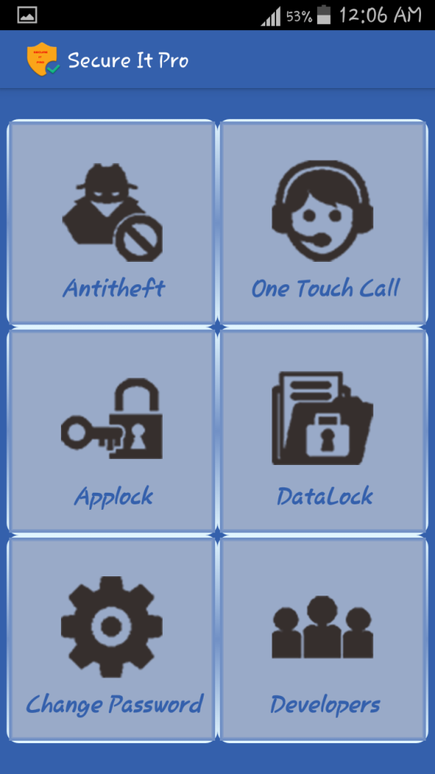
2. Antitheft Registration Form:-
- When Anti Theft App is selected a simple registration form will be
Displayed.

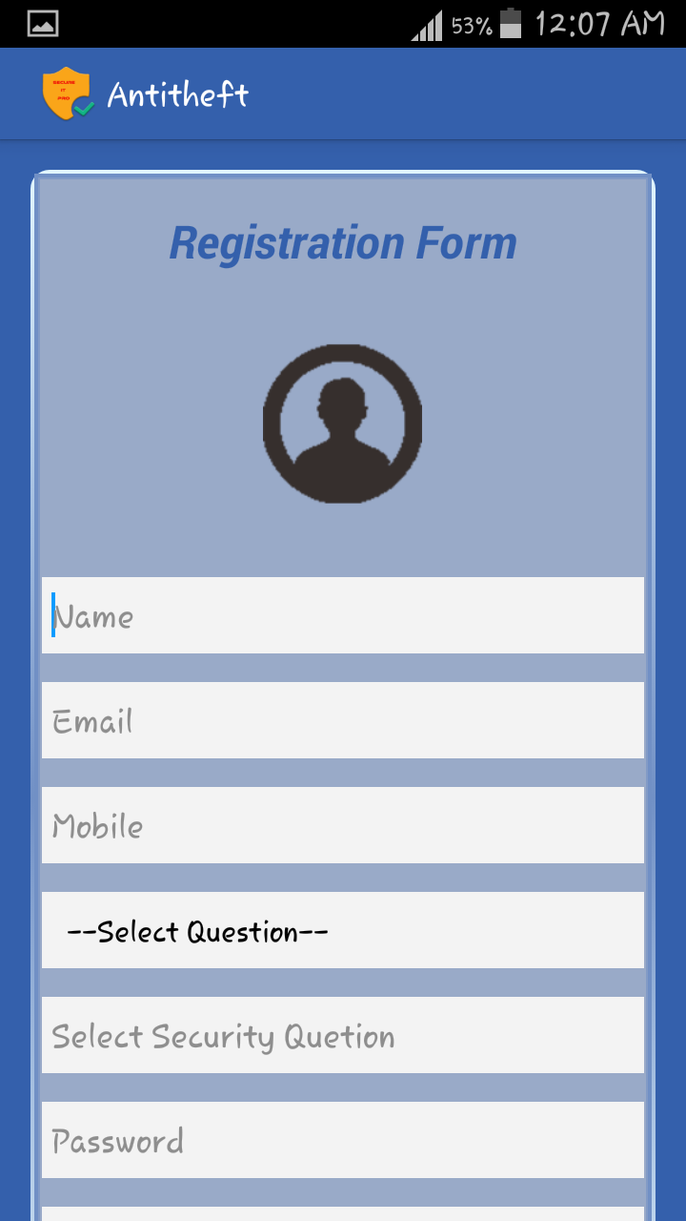

3. Antitheft Select Phone Number :-
- Once a registration form is filled. User Login ID and password is stored.

- On Clicking the “Set Mobile Number” Button we will move to This Screen.

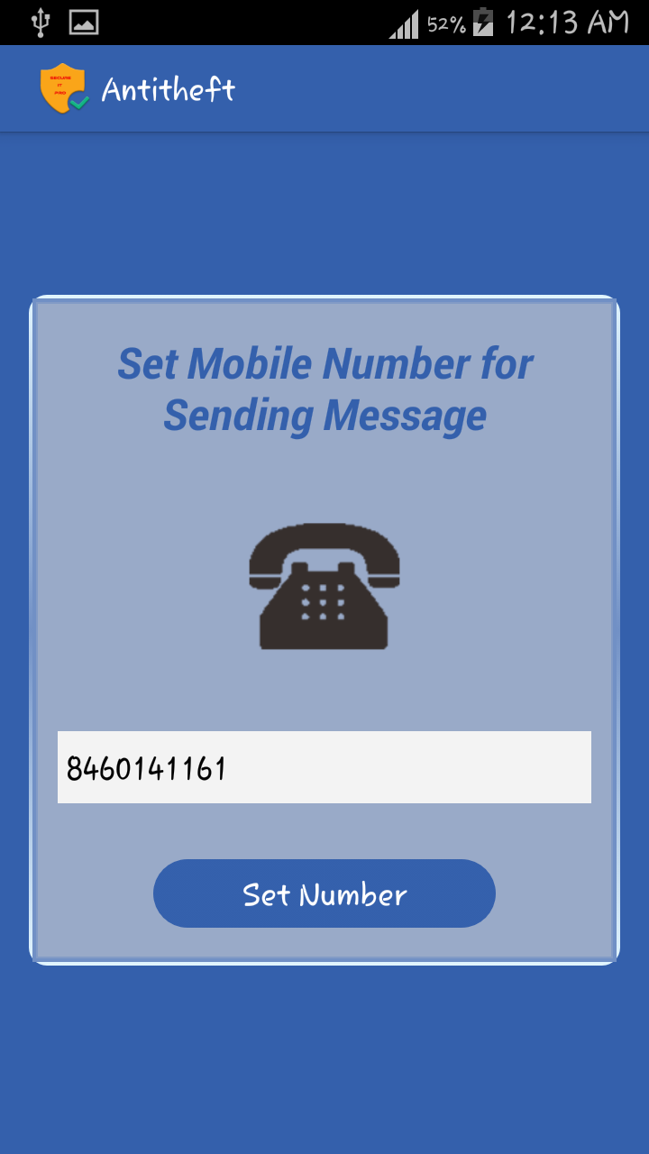
4. OneTouch Select Phone Number :-
- Here we can set Mobile Number on which we want to call by single
touch.

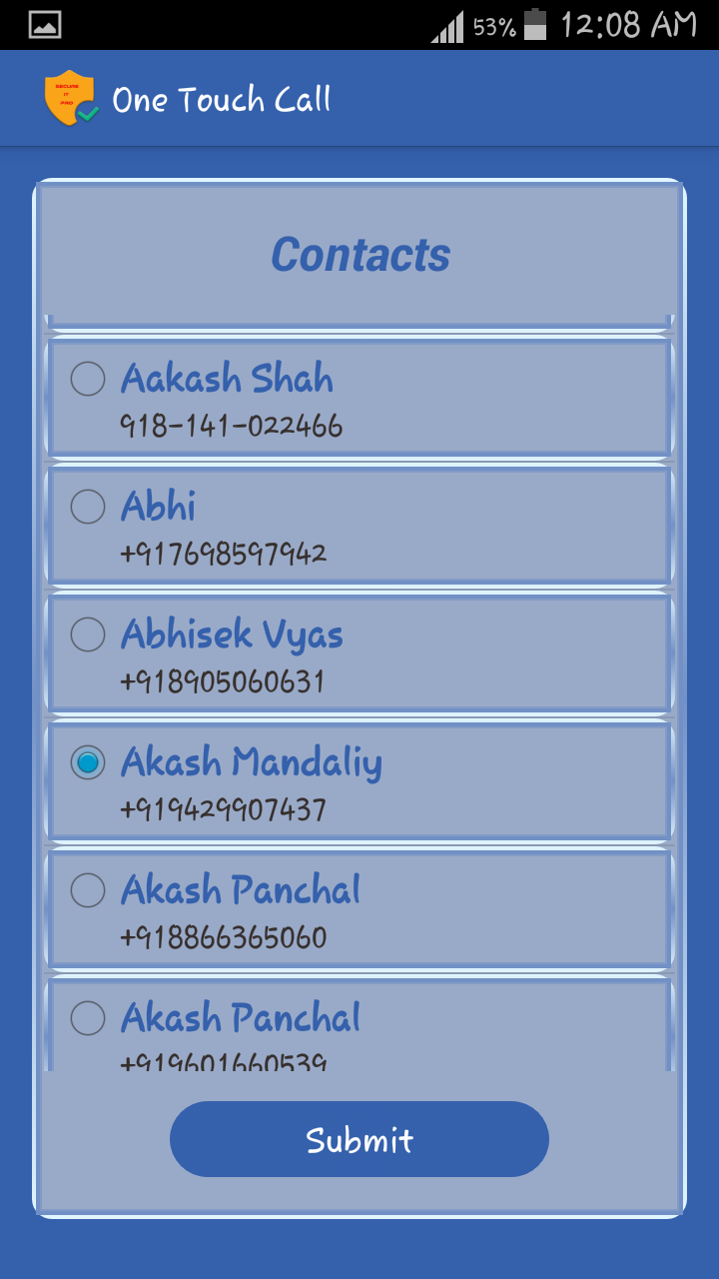
5.One Touch Call :-
- Here the selected phone number will be displayed.

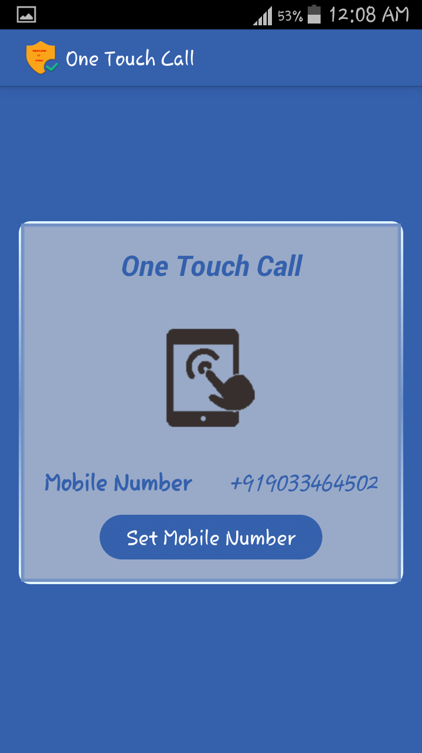
6. Data Hiding Select File :-

- After clicking Data hiding icon, File explorer is opened.

- Just route the file and select the one file that you want to hide.

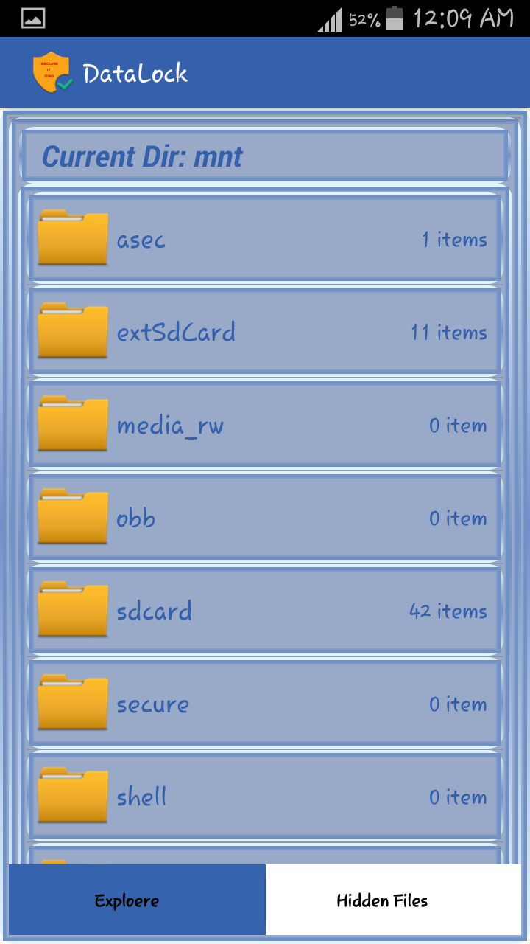
7. Data Hiding Hidden Files :-

- By clicking hidden files we can see those files which are hidden.

- Just long press any files and unhide it.

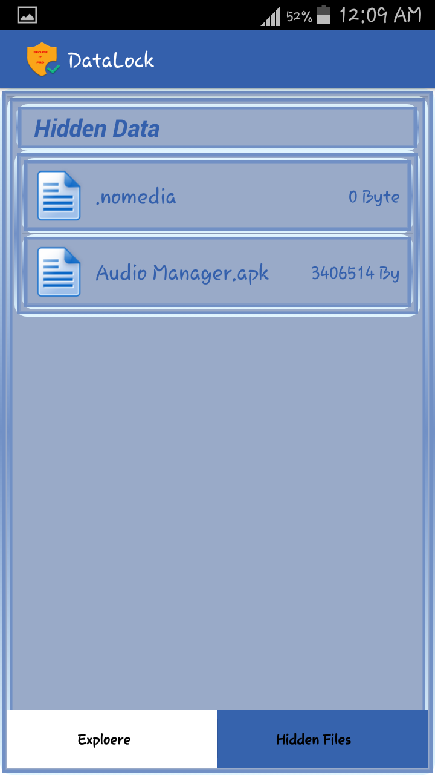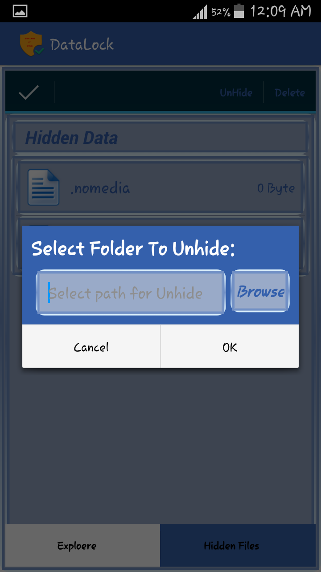

8. AppLockScreen :-

- This is a LockScreen which will display when the apps selected by user will be in foreground.

- On Entering a Correct Password we need to click on OK Button. So we get access to that app.

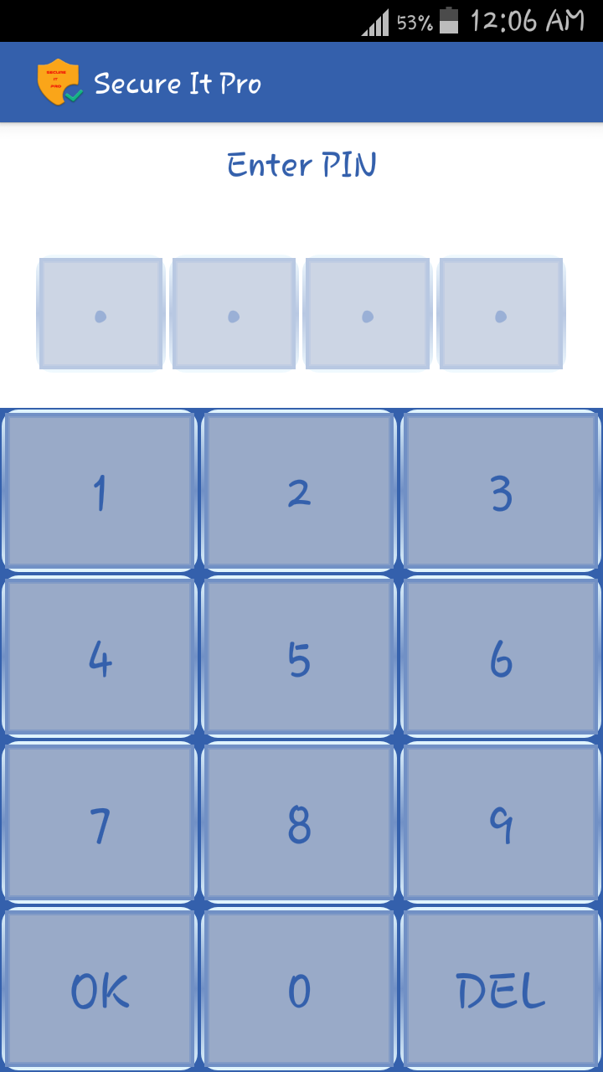

9. Applock App Selection :-

- From the list of installed app select those apps which you want to
Protect.

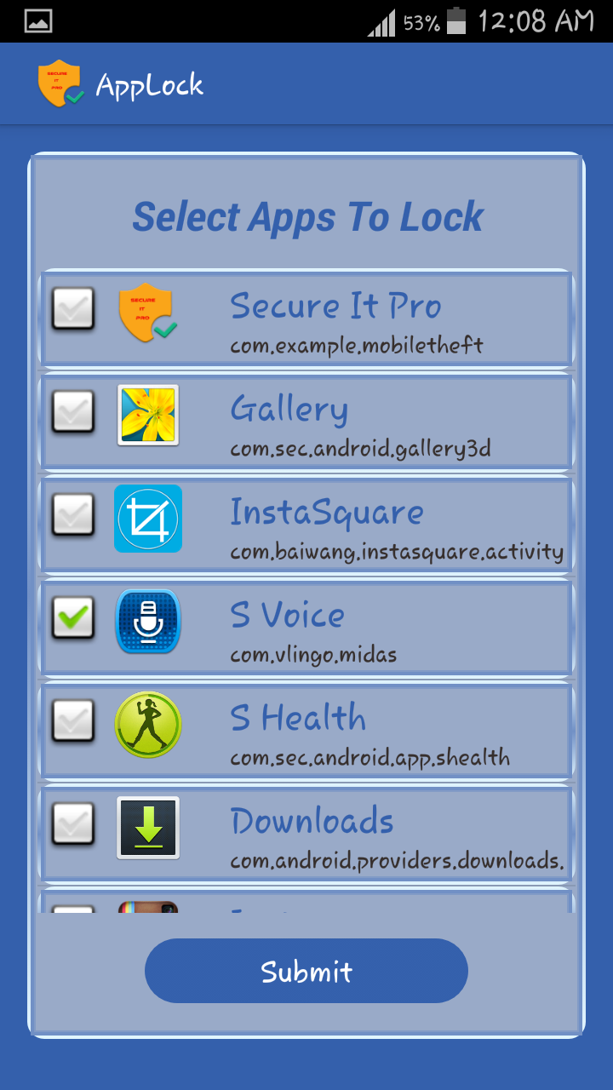

10.Applock Selected App :-

- Selected Apps Will be displayed here.

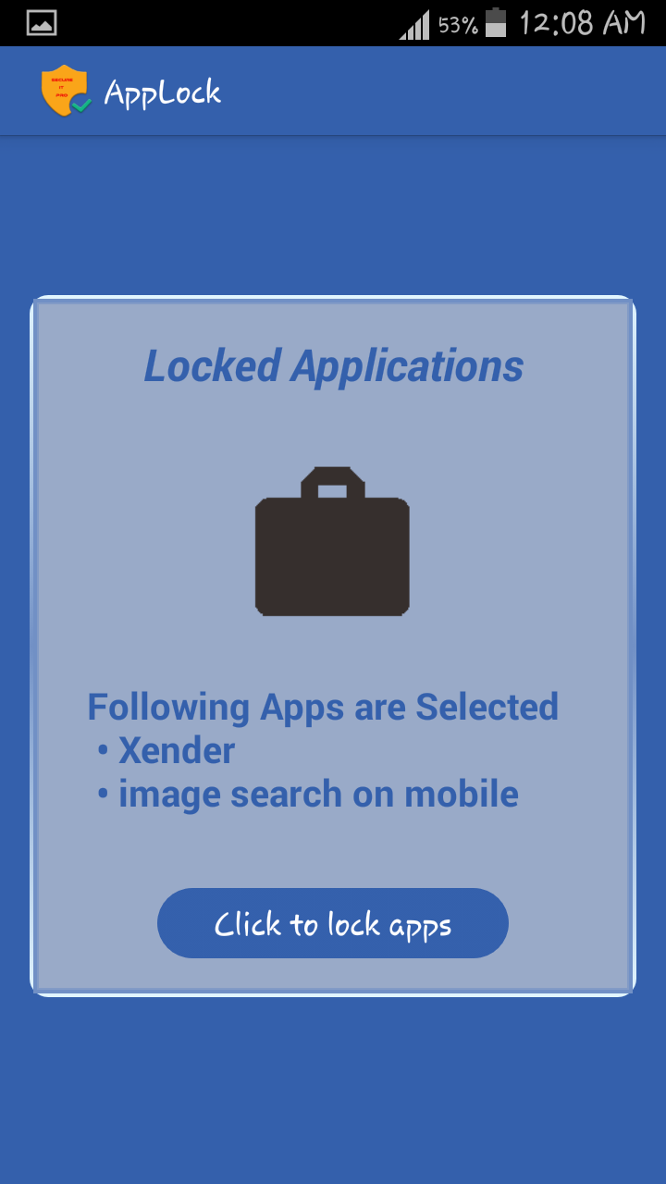
11. Secure IT ProLogin :-

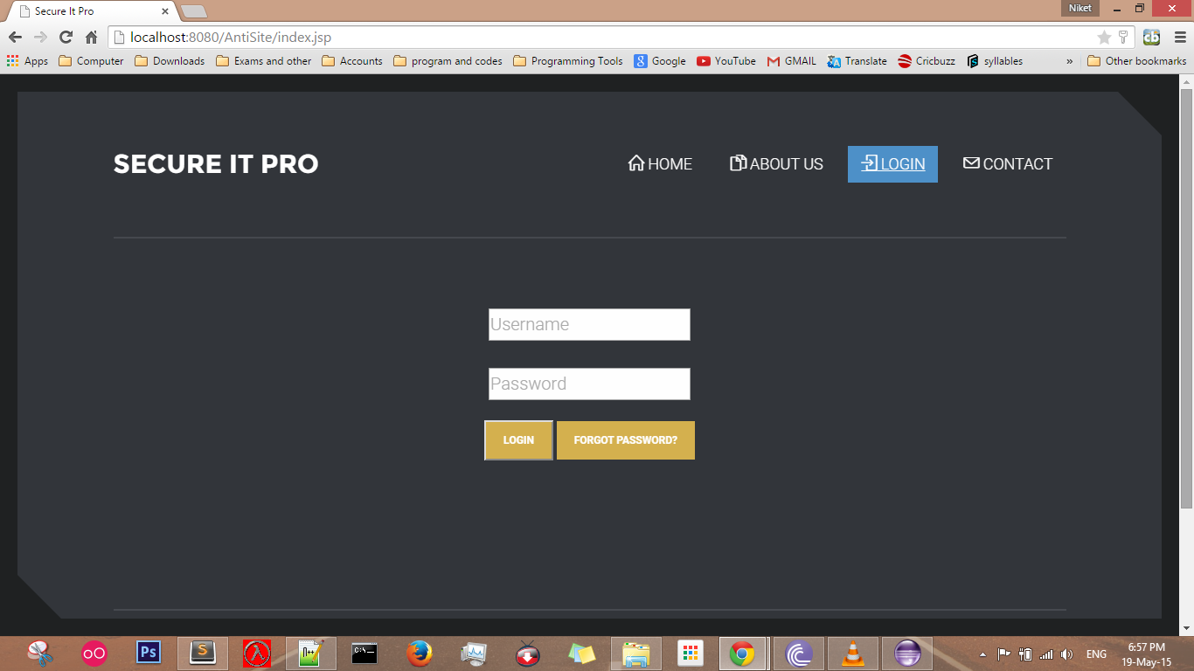
12.Secure IT Pro Trace Location :-

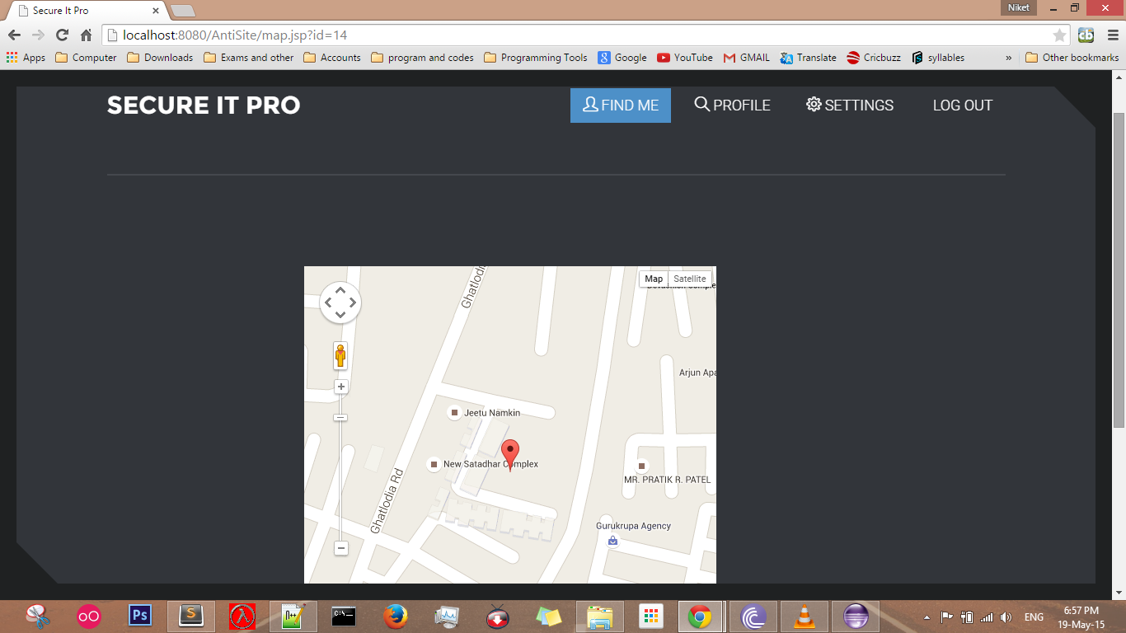

13.Secure IT Pro User Profile :-

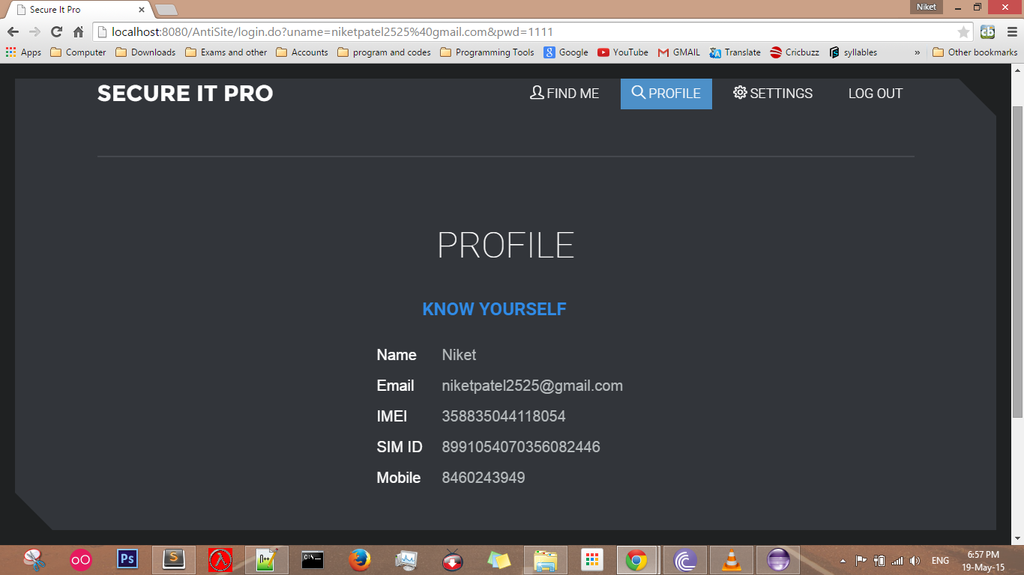
14.Secure IT Pro Change Password :-

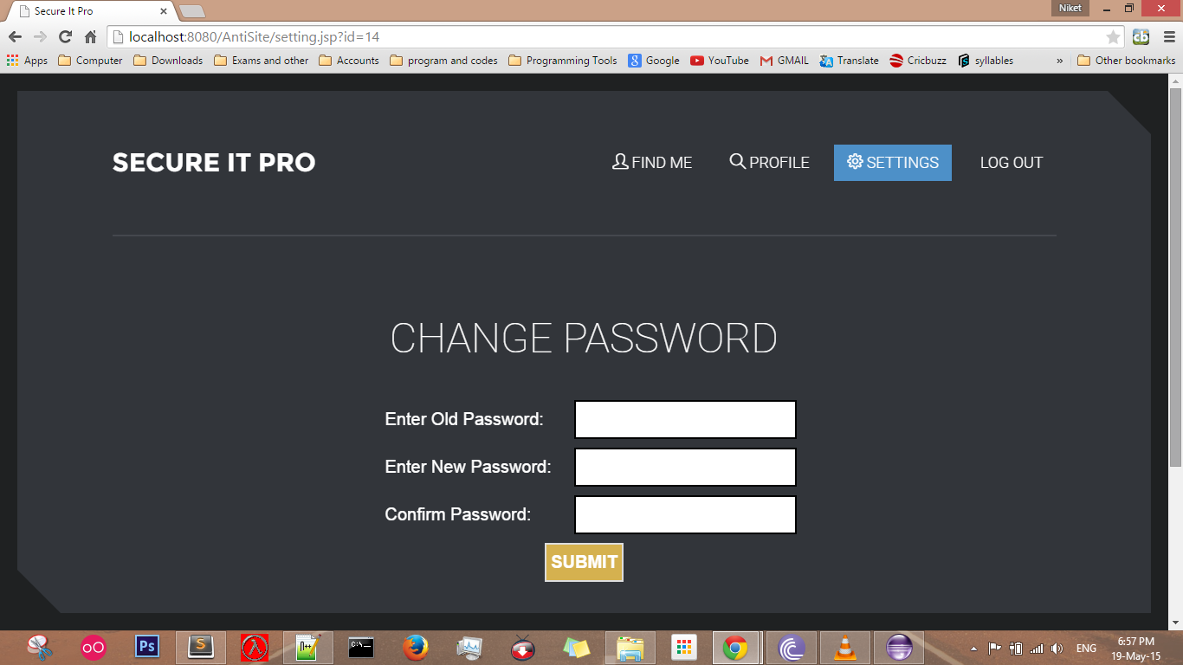

6.2 Data Dictionary
- AntiTheft Login
This table contain the details of user.
Primary key : id
Field Name | Type | Size | Allow Null | Description
id | int | 15 | N | User ID
emailid | varchar | 150 | N | Email ID of user
password | varchar | 20 | N | Password of user
active | boolean |  | Y | Status of user

- AntiTheft Profile Detail
This table contain the details of user profile.
Primary key: id
Field Name | Type | Size | Allow Null | Description
id | int | 15 | N | User ID
name | varchar | 150 | N | User Name
emailid | varchar | 150 | N | Email ID of user
mobile_number | varchar | 15 | N | Mobile Number of user
sim_number | varchar | 45 | N | Sim Number of card.
IMEI | varchar | 15 | N | IMEI number of user mobile.

- AntiTheftLocation
This table contain the details of user mobile location.
Primary key: id
Field Name | Type | Size | Allow Null | Description
id | int | 15 | N | User ID
longitude | varchar | 45 | N | Logitude of location
latitude | varchar | 45 | N | Latitude of location
time | timestamp |  | N | Time when mobile is traced.

4.AntiTheftSec_Que
This table contain the Security details of user.
Primary key: id
Field Name | Type | Size | Allow Null | Description
id | int | 15 | N | User ID
question | varchar | 45 | N | Security question
answer | varchar | 45 | N | Security answer

6.3 Code Details (Code Snippet)

- Andoridmanifest.xml

Set Permission:
- <uses-permission android:name="android.permission.RECEIVE_BOOT_COMPLETED" />
Application Activity:
- <application
android:allowBackup=“true”
android:icon=“@drawable/ic_laucher”
android:label=“@string/app_name”
android:theme=“@style/AppTheme”
<activity
android:name=“.RegistrationForm”
android:label=“@string/app_name”>
</activity>
<application>

Recevier:
- <receiver android:name="receiver.StartUpdateLocationServiceIfNot"
- android:enabled="true"
- android:exported="true"
- android:permission="android.permission.RECEIVE_BOOT_COMPLETED" >
- <intent-filter>
- <action android:name="android.intent.action.BOOT_COMPLETED" />
- <action android:name="android.intent.action.QUICKBOOT_POWERON" />
- <action android:name="android.intent.action.USER_PRESENT" />
<action android:name="android.intent.action.ACTION_SHUTDOWN" />
<category android:name="android.intent.category.HOME" />
<category android:name="android.intent.category.DEFAULT" />
</intent-filter>
</receiver>

- mainmodule.java

TableLayout:
- <TableLayout
- android:layout_width="wrap_content"
- android:layout_height="wrap_content"
- android:layout_gravity="center_horizontal"
- android:layout_weight="0.5"
- android:gravity="center_horizontal" >
- <TableRow
- android:layout_width="wrap_content"
- android:layout_height="wrap_content"
- android:layout_gravity="center_horizontal"
- android:gravity="center_horizontal" >
- </TableRow>
- </TableLayout>

- Item.java

public class Item implements Comparable<Item> {
private String name;
- private String data;
- private String date;
- private String path;
- private String image;
public Item(String n, String d, String dt, String p, String img) {
- name = n;
- data = d;
- date = dt;
- path = p;
- image = img;
- }
- public String getName() {
- return name;
- }
- public String getData() {
- return data;
- }
- public String getDate() {
- return date;
- }
- public String getPath() {
- return path;
- }
- public String getImage()
- {
- return image;
- }
- public intcompareTo(Item o) {
- if (this.name != null)
  - return this.name.toLowerCase().compareTo(o.getName().toLowerCase());
- else
- throw new IllegalArgumentException();
- }

- AppLockShowApplist.java

private List<ApplicationInfo>getModel(List<ApplicationInfo> list) {
aList = new ArrayList<ApplockAppList>();
List<ApplicationInfo>applist = new ArrayList<ApplicationInfo>();
for (ApplicationInfo info : list) {
if (packageManager.getLaunchIntentForPackage(info.packageName) !=
null) {
applist.add(info);
String n = info.loadLabel(packageManager).toString();
System.out.println("packagename:" + n);
int i = info.icon;
aList.add(get(n));
}
return applist;}

- DataHidingExplore.java
public booleanonActionItemClicked(ActionMode mode, MenuItem item) {
switch (item.getItemId()) {
case R.id.delete: {
Toast.makeText(getBaseContext(),"Delete selected“+getListView().getCheckedItemCount(),Toast.LENGTH_LONG).show();
return true;
}
case R.id.edit: {
getCheckedItems();
return false;
}
}

- AntitheftSetMobile.java
public void onClick(View v) {
tringmobilenum = eMobile.getText().toString();
if (mobilenum.length() >= 10 &&mobilenum.length() <= 12) {
Editor confirmEdit = getPref.edit();
confirmEdit.putString("Antitheft_stored_mobile", mobilenum);
confirmEdit.commit();
Intent ourIntent = new Intent(getApplicationContext(),AntitheftFrontPage.class);
startActivity(ourIntent); } else {
showWarningMessage("Insert valid Mobile Number.");
}
}

7. OneTouchCallFrontPage.java
- public void onClick(View v) {
- switch (v.getId()) {
- case R.id.bOneTouchSelectContact:
- Intent iContact;
- try {
- iContact = new Intent(getApplicationContext(),ContactList.class);
- startActivity(iContact);
- } catch (Exception e) {
- e.printStackTrace();
- }
- break;

7 Testing

Test Plan and Test Method
Test Case

7.1 Test Plan And Test Method

7.1.1 Test Plan

A test plan is a document detailing a systematic approach to testing a system such as amachine or software. The plan typically contains a detailed understanding of what theeventual workflow will be.A test specification is called a test plan. The developers are well aware what test planswill be executed and this information is made available to management and the developers.The idea is to make them more cautious when developing their code or making additionalchanges. Some companies have a higher level document called a test strategy.

7.1.2 Test method

The objective of the testing is to find the greatest possible number of error withmanageable amount of effort apply over a realistic time span.There are two basic classes of software testing , black box testing and white boxtesting.

Black box testing (also called functional testing) is testing that ignores the internal
mechanism of a system or component and focuses solely on the outputs generated in responseto selected inputs and execution conditions.

White box testing (also called structural testing and glass box testing) is testing thattakes into account the internal mechanism of the system or component.

7.2 Test Cases

In software engineering, the most common definition of a test case is a set ofcondition or variables under which a tester will determine if a requirement or use case uponan application is partially or fully satisfied. It may take many test cases to determine that arequirement is fully satisfied. In order to fully test that all the requirement unless arequirement has sub requirements. In that situation ,each sub requirement must have at leastone test case.

7.2.1 Test Case for User Login[Valid]

Purpose | Login is used for tracing his mobile and also to view and update profile.
Prereq | For login user must be registered through mobile device.
Test Data | EmailID = {valid emailID}  Password = {valid password}
Steps | Steps to carry out the test  1.Visit the login page  2.Enter emailID  3.Enter password  5.Enter Login Button  6.Verify message of successful login.  7.Visit Home page.
Notes and Question | Note :- Password must be atleast 6 characters.

7.2.2 Test Case for User Login[Invalid]

Purpose | Login is used for tracing his mobile and also to view and update profile.
Prereq | For login user must be registered through mobile device.
Test Data | EmailID = {invalid,emailID,empty}  Password = {invalid,password,empty} or  EmailID={valid,emailID}  Password={invalid,empty} or  EmailID= {empty}  Password= {empty}
Steps | Steps to carry out the test  1.Visit the login page  2.Enter emailID  3.Enter password  5.Enter Login Button  6.Verify message of invalid emailID or password..  7.Go back to login page.
Notes and Question | Note :- Password must be atleast 6 characters.

7.2.3 Test Case for User Registration

Purpose | User Registration is used for login and user profile.
Prereq | For user registration, user must need to fill all the details of registration form.
Test Data | Name ={valid name,invalidname,empty}  Email={valid Email,invalidEmail,empty}  Mobile={valid Mobile,invalidMobile,empty}  Password={valid Password,invalidPassword,empty}  Confirm password={valid confirm password,invalid confirm password,empty}
Steps | Steps to carry out the test  1.Visit the Registration Form page.  2.Enter the required details.  3.Click on Submit.  4.See Home Page.  5.Verify the message.
Notes and Question | Note:- Password must be atleast 6 characters.

8 Future Plan and Conclusion

Future Plan
Conclusion

8.1 Future Plan

The Ideal scope for any system should be that it should be everlasting. But we know that, in today’s world, anything cannot be everlasting as things change within seconds. So, out system cannot be everlasting, as one should always keep pace with the requirement. In Future, we will provide encryption-decryption to protect our data. We will also provide remote phone locking system and offline mobile tracing system also. We will provide pattern lock apart from password to lock mobile.

8.2 Conclusion

The scope of the project has been described and it will able to provide security to data, mobile, application etc. This application offers best GUI to users and take care of android device resources as well.

9 Bibliography

Websites
Books

9.1 Websites

- http://developer.android.com/develop/index.html
- http://developer.android.com/training/index.html
- http://developer.android.com/guide/components/index.html
- http://developer.android.com/google/index.html
- http://stackoverflow.com/
- http://www.technotalkative.com/android/
- http://www.technotalkative.com/adt-bundle-a-single-step-to-setup-android-development-environment/
- http://developer.android.com/reference/android/telephony/TelephonyManager.html

9.2 Books

- Software engineering By Roger Pressman
- Android Programming: The Big Nerd Ranch Guide
- Programming Andorid Ziguard Mednieks

10 Appendix

Periodic Progress Reports (PPR)
Business Model Canvas
Business Model Canvas Report
Patent Drafting Exercise (PDE)

10.1 Periodic Progress Reports (PPR)

10.2 Business Model Canvas & Report

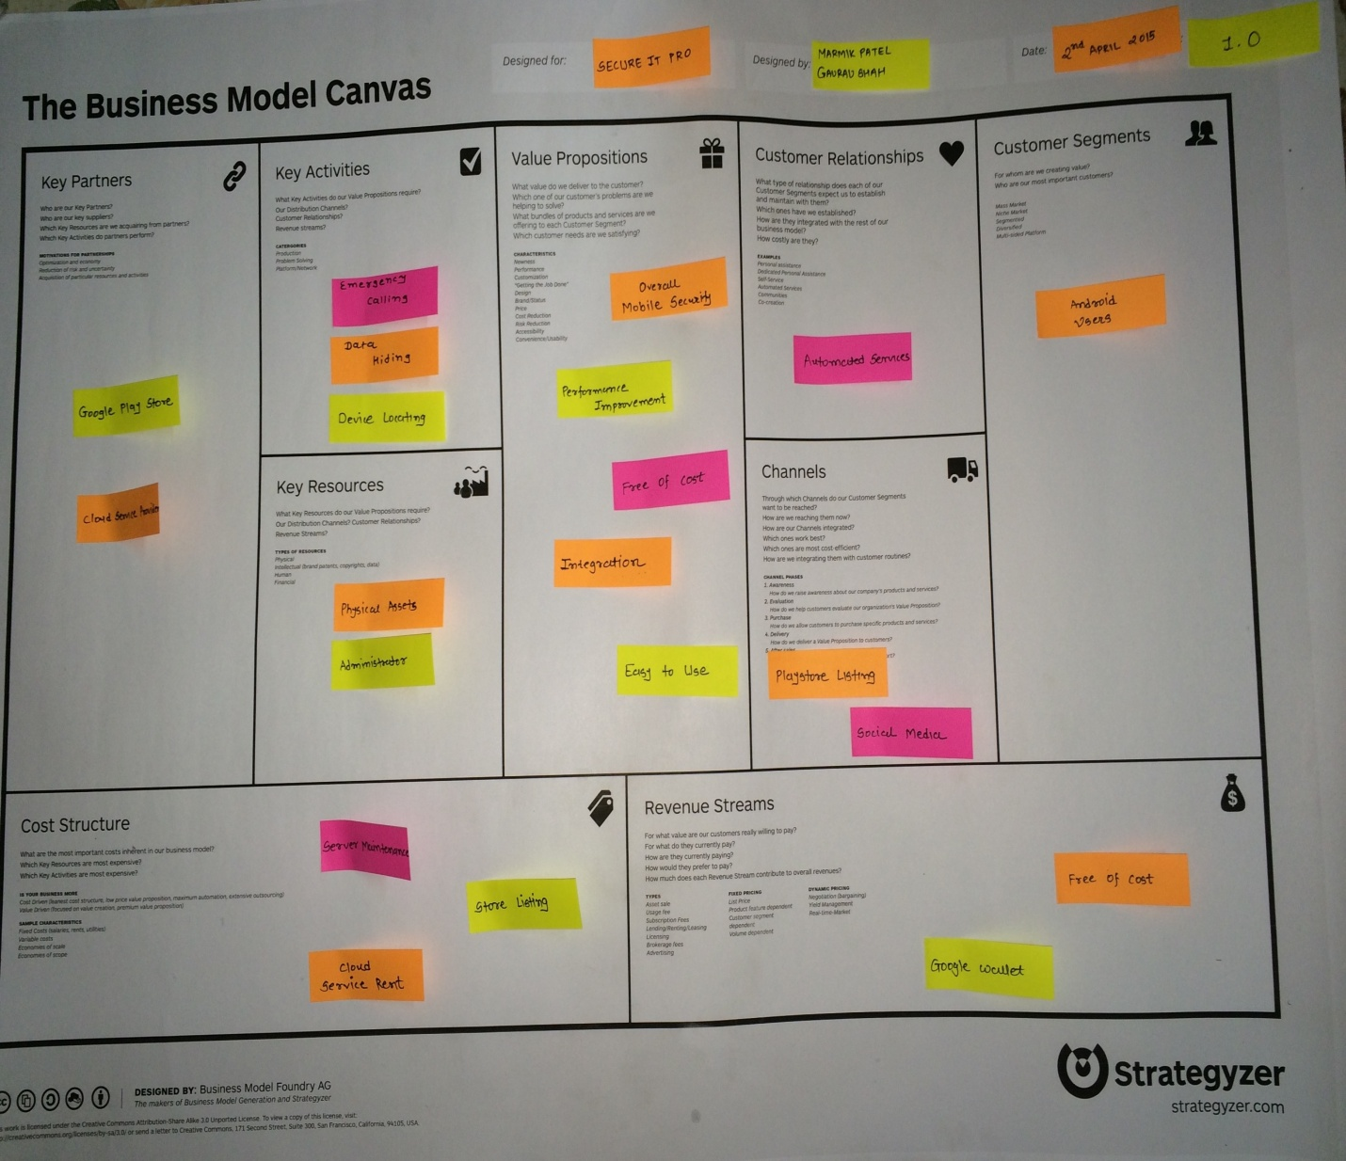

Report
On
Business Model Canvas
For Project
"Secure It Pro"

Prepared By
Group ID: 7478/17292
Marmik N. Patel (110280107003)
Niket B. Patel (110280107017)
Gaurav P. Shah (110280107020)
Nisarg H. Shah (110280107050)

Submitted to
Department of Computer Engineering
L .D COLLEGE OF ENGINEERING
Affiliated to
Gujarat Technological University, Ahmedabad
May , 2015

INDEX

• Customer Segments 3
• Value Propositions 3
• Channels 3
• Customer Relationship 3
• Revenue Streams 4
• Activities 4
• Resources Key 4
• Key Partnership 4
• Cost Structures 4

Business Model Canvas
- Customer Segments
  - Android Users are the customers who uses smart phone based on android operating systems. They install this application for the security of mobile, hiding of data etc.

- Value Propositions
  - Overall Mobile Security features provides various security functionalities to android mobile.
  - Due to overall security functionalities in single application there is an improvement in performance of application.
  - One of the important feature of application is that it is available free of cost and user can download it from google play store.
  - Due to consistent and simple user interface application is easy to use for user.

- Channels
  - Social media is the best channel for the connect to the people for Attract the our software which
  - give the advance features of the system.
  - Google Play Stores is the also biggest channel for publishingthe ourapp which provided by Google Inc.

- Customer Relationship
  - This application is totally automated service which does not require any relationship with providers and customer can use it by downloading and registering with it by free of cost.

- Revenue Streams
  - This application is free of cost so there is no need to pay for using this application.
  - In future ,customer can buy some extra features through google wallet.

- Activities
  - Calling by single touch. By this feature user can call pre selected number by single click.
  - Data Hiding features facilitates authorized access to personal documents by hiding them.
  - Device Locating is most attractive feature of this application. This feature track android mobile whenever sim card is changed and password entered is wrong.

- Resources Key
  - Physical assets such as mobile phones, personal computers are required for this app.
  - Administrator is responsible for managing updates , server for website.

- Key Partnership
  - Google Play Store and Cloud Service Provider is key partners of the our software.

- Cost Structures
  - Cost Structure of project is mainly depends on server maintenance, rent of cloud service provider and cost of publishing application in Google Play Store.

10.3 Patent Drafting Exercise Report

